**1**

MSc Data Science Project

7PAM2002-0509-2023

Department of Physics, Astronomy and Mathematics

**Data Science FINAL PROJECT REPORT**

**Project Title:**

Enhancing the Accuracy of ML AND DL Models in Phishing Detection

**Student Name and SRN:**

Ankarapu Renusri and 21032372

Supervisor: Man Lai Tang

Data submitted: 29th August 2024

Word Count: 9931

**MSc Final Project Declaration**

This report is submitted in partial fulfillment of the requirement for the degree of Master of Science in Data Science at the University of Hertfordshire.

I have read the guidance to students on academic integrity, misconduct and plagiarism information at [Assessment Offences and Academic Misconduct](https://www.herts.ac.uk/__data/assets/pdf_file/0007/237625/AS14-Apx3-Academic-Misconduct-v17.0.pdf) and understand the University process of dealing with suspected cases of academic misconduct and the possible penalties, which could include failing the project module or course.

I certify that the work submitted is my own and that any material derived or quoted from published or unpublished work of other persons has been duly acknowledged. (Ref. UPR AS/C/6.1, section 7 and UPR AS/C/5, section 3.6). I have not used ChatGPT, or any other generative AI tool, to write the report or code (other than where declared or referenced).

I did not use human participants or undertake a survey in my MSc Project.

I hereby give permission for the report to be made available on module websites provided the source is acknowledged.

Student Name printed: Ankarapu Renusri

Student Name signature:

**Acknowledgement**

As I come close to finishing my post-graduate studies, I would like to emphasize that it has been a wonderful learning experience, and I want to express my gratitude to all the people who have supported me along the way.

I'd like to start by expressing my gratitude to Almighty God for never ceasing to inspire me with His endless blessings and for giving me the confidence and valor to move forward with assurance and self-belief.

I would like to convey my appreciation and gratitude to Man Lai Tang, who served as my supervisor, for her constant advice and assistance in this project. I am appreciative of her constant support and her patience towards my inquisitiveness.

I would also like to express my gratitude towards all my professors at the University of Hertfordshire who helped me gain knowledge and understanding of the subjects and helped me throughout my course.

I would also like to thank my parents, my sister, and my friends for their unwavering encouragement and support, without which this would not have been possible.

**Abstract**

In order to shape and advance this student project, I would like to sincerely thank my committed Project Supervisor, Mr. Man Lai Tang, for his important assistance, direction, and advice. His knowledge and thoughts have been extremely helpful in the growth and development of his study.

I would like to express my sincere gratitude to the University of Hertfordshire, especially the School of Physics, Engineering, and Computer Science, for providing the facilities, structure, and welcoming atmosphere that made this research possible. The experience was satisfying and enlightening because of the faculty and staff’s collective wisdom and unity

I would like to express my sincere gratitude to all of the writers, scholars, and industry pioneers whose writings and extensive research served as the foundational sources for this project. Thanks to your persistent efforts, newcomers like me now have the chance to learn more about this interesting field of research.

Last but not least, I’d like to express my gratitude to everyone who has helped me in various ways and made my project possible. Your support has been crucial in helping me stay inspired and concentrated.

**Contents**

Contents

1. Introduction 6

2. Literature Review 8

3. Methodology 11

**Brief Overview: 11**

3.1 Dataset Description 11

3.2 Data Preprocessing 12

3.3 Feature Engineering 13

3.4 Model Selection 14

3.5 Experimental Setup 15

3.6 Model Evaluation Metrics 16

4. Comparison of ML and DL Models 17

5. Discussion of Results 17

6. Chapter: Experimental Evaluation 18

6.1 Comparison of ML and DL Models 18

7. Discussion of Results 21

8. Results 25

9. Conclusion 27

10. Future Work 28

11. References 32

# Introduction

Phishing, a prevalent cyber threat, continues to jeopardize the security of individuals and organizations by deceiving users into divulging sensitive information through deceptive URLs and websites. Traditional methods of phishing detection, such as heuristic-based approaches and blacklist systems, are increasingly inadequate against the evolving sophistication of phishing techniques. These techniques frequently find it difficult to keep up with malicious URLs' dynamic nature, which is always changing in order to avoid detection and take advantage of security holes (Suleman & Awan, 2019).

The use of machine learning (ML) algorithms has become a viable strategy to improve the efficacy and precision of phishing detection systems in response to these difficulties. This research focuses on evaluating and comparing several ML techniques for URL-based phishing detection, including decision tree algorithms, random forests, MLPs, SVMs, and LSTM networks. Each of these algorithms offers unique advantages in analyzing URL features such as domain characteristics, lexical cues, and structural patterns to differentiate between legitimate websites and phishing attempts.

Decision tree algorithms provide a transparent and interpretable framework for classifying URLs based on distinct features, enabling cybersecurity analysts to understand the decision-making process behind phishing detection (Thakur et al., 2023). Random forests, leveraging ensemble learning, further enhance detection by aggregating decisions from multiple decision trees, thereby improving robustness against variability in data (Marakhimov et al., 2022). MLPs, known for their ability to learn complex patterns through layers of neurons, offer a deep learning approach to capturing intricate relationships within URL datasets (Shekokar et al., 2015). SVMs excel in separating URL instances in high-dimensional spaces using kernel functions, making them effective in nonlinear classification tasks (Jiang et al., 2021). LSTM networks, with their sequential learning capability, are adept at capturing temporal dependencies in URL sequences, which is crucial for detecting subtle phishing patterns over time (Choo et al., 2017).

By analyzing parameters including accuracy, precision, recall, and F1-score, this study seeks to provide empirical insights into how well certain machine learning algorithms work for URL-based phishing detection. This study compares the efficacy of MLP, SVM, LSTM, decision tree, random forest, and other algorithms in order to offer useful recommendations for implementing resilient and adaptable phishing detection systems in practical cybersecurity applications.

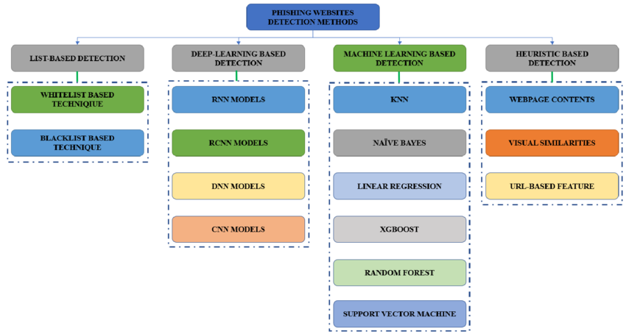

Fig:1.1 Machine learning method for Phishing Detection

# Literature Review

1. Phishing Website Detection Using Machine Learning In their investigation into the use of machine learning to identify phishing websites, Suleman and Awan (2019) highlighted the drawbacks of more conventional detection techniques like blacklists and offered a fresh strategy. Their research highlighted how machine learning algorithms could enhance detection accuracy by analyzing various URL features. They particularly showed how well a machine learning model works for categorizing phishing websites according to traits like URL length, domain age, and questionable phrases. This seminal work established the significance of machine learning in overcoming the shortcomings of conventional phishing detection techniques, thereby laying the framework for further research.

2. Decision Tree Algorithm for Phishing Detection Thakur, Thakur, and Thakur (2023) provided an in-depth analysis of the application of decision tree algorithms in phishing detection. Their work emphasized the interpretability and efficiency of decision trees in classifying URLs based on specific attributes, making them a robust choice for real-time phishing detection. The study also discussed the integration of decision trees with other machine learning techniques to optimize performance, highlighting how decision trees could be enhanced to mitigate issues such as overfitting and to improve accuracy in identifying phishing sites. This research is particularly relevant for the development of decision tree-based models in phishing detection.

3. Random Forest Approach for Phishing Detection Marakhimov, Ji, and Lee (2022) expanded on the use of ensemble learning techniques, specifically random forests, in phishing detection. Random forests, which aggregate decisions from multiple decision trees, were shown to improve robustness against the variability in data, leading to higher accuracy and reliability in phishing detection. This study demonstrated that random forests could effectively handle large and diverse datasets, making them suitable for deployment in environments where phishing tactics are constantly evolving. The research also provided insights into the potential of combining random forests with other machine learning algorithms to further enhance detection capabilities.

4. Support Vector Machine (SVM) in Phishing Detection Jiang, Wang, and Wei (2021) explored the application of Support Vector Machine (SVM) algorithms in phishing detection, particularly focusing on their ability to classify URLs in high-dimensional spaces. SVMs were found to be effective in separating phishing URLs from legitimate ones, particularly in cases where the URL features exhibited nonlinear relationships. The study also discussed the challenges associated with SVMs, such as the need for appropriate kernel selection and parameter tuning, but concluded that SVMs remain a powerful tool in phishing detection, especially when combined with other techniques.

5.LSTM and Deep Learning in Cybersecurity In their 2017 study, Choo, Liu, and Li focused on intrusion detection while examining the use of deep learning, namely Long Short-Term Memory (LSTM) networks, in cybersecurity. Their study demonstrated how LSTMs, with their ability to capture temporal dependencies in sequential data, could be leveraged to detect sophisticated phishing attacks that evolve over time. The research highlighted the advantages of LSTM networks in processing sequences of URL data, making them particularly effective in detecting phishing attempts that involve time-based or sequential patterns. This work is crucial for understanding how deep learning models like LSTMs can complement traditional machine learning approaches in phishing detection.

6. Multi-Layer Perceptron (MLP) in Phishing Detection Shekokar, Thakur, and Chavan (2015) discussed the use of Multi-Layer Perceptron (MLP) models in phishing URL detection. As a kind of feedforward neural network, MLPs have demonstrated the ability to learn intricate patterns from big datasets, which makes them a good fit for the classification tasks involved in phishing detection. The study emphasized how crucial feature engineering and data pretreatment are to improving MLP model performance. The potential of MLPs in conjunction with other models was also highlighted by the authors, who hypothesized that an ensemble approach may further increase detection accuracy.

7.Multiple Machine Learning Techniques for the Detection of Phishing Websites Shreya Gopal's (2021) GitHub project offers a useful application of several machine learning algorithms for phishing website identification. Models including Decision Tree, Random Forest, MLP, SVM, and LSTM are available in the repository, and their performance on phishing detection tasks can be thoroughly compared. This work is significant as it provides hands-on examples of how these models can be trained, tested, and deployed in a real-world context. The project is a useful tool for researchers and practitioners alike since it shows how combining various machine learning models can improve the overall accuracy and robustness of phishing detection systems.

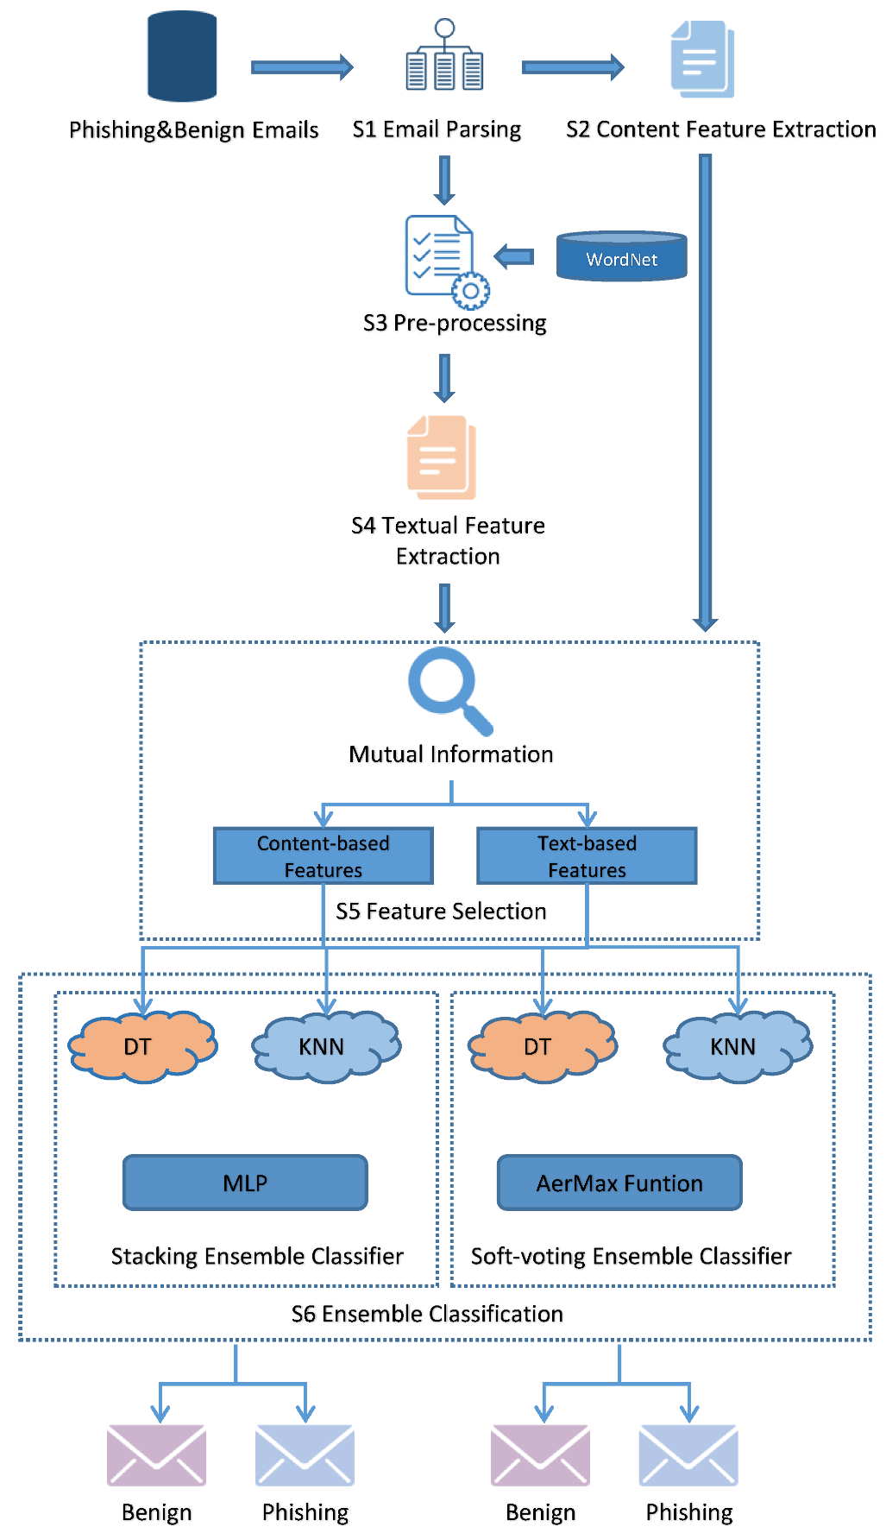

Fig:2.1 Flowchart of phishing detection

# Methodology

# Brief Overview:

This chapter describes the all-encompassing approach used to use Machine Learning (ML) and Deep Learning (DL) models to improve the accuracy of phishing detection. A thorough explanation of the dataset, the preprocessing steps that were performed on it, the feature engineering techniques that were created, the selection and application of different ML and DL models, the experimental setup, and the evaluation metrics that were used to gauge the models' performance are all included in the methodology.

## 3.1 Dataset Description

The dataset used in this study is taken from the popular URL 2016 dataset, which includes both benign and phishing URLs. This dataset is particularly suitable for phishing detection studies due to its rich diversity of features and its balanced representation of legitimate and phishing websites.

Features: The dataset consists of 80 features, which can be broadly categorized into three types:

1. Lexical Features: These come from the content and structure of the URL itself. Examples include the URL's length, the number of subdomains, and the use of special characters like underscores or hyphens. Lexical features are crucial because phishing URLs often differ subtly from legitimate ones, using tactics like adding extra characters or mimicking popular domain names.
2. Host-Based Features: These features relate to the server hosting the URL. They include the domain’s registration information, the time since the domain was registered, the presence of HTTPS, and the geographical location of the server. Host-based features are valuable because phishing websites often have short lifespans, newly registered domains, or suspicious hosting details.
3. Content-Based Features: These features analyze the actual content of the web page. They include the presence of specific keywords, the structure of the HTML, and the presence of embedded forms or links. Content-based features are critical because phishing pages are designed to mimic legitimate sites, often using similar content or layout.

Dataset Size and Distribution: The dataset includes tens of thousands of URLs, with an almost equal distribution of phishing and benign URLs, ensuring that the models do not become biased toward either class. This balanced distribution is essential for training robust models capable of detecting phishing URLs without a high rate of false positives.

Dataset Challenges: Despite its richness, the dataset presents challenges such as noisy data, redundant features, and the potential for overfitting, especially given the complex nature of phishing detection. Addressing these challenges requires careful preprocessing and feature engineering, which are discussed in the subsequent sections.

## 

## 3.2 Data Preprocessing

An essential step in getting the dataset ready for analysis is data preparation. To optimize the performance of the ML and DL models, the data must be cleaned, transformed, and arranged. The dataset was processed using the subsequent steps:

1. Handling Missing Values:
   * In large datasets, missing data is a prevalent problem that can seriously affect model performance. In this dataset, missing values were found in some host-based and content-based features. To address this, imputation techniques were applied. For numerical features, the median was used to replace missing values, as it is less sensitive to outliers. For categorical features, the mode was used. In cases where a feature had too many missing values (more than 30%), it was either discarded or replaced with a default value indicating the absence of information.
2. Encoding Categorical Variables:
   * For machine learning models, it is necessary to transform categorical variables—like geographic location or domain registration information—into a numerical format. Nominal categorical characteristics underwent one-hot encoding to produce binary columns for every category. Label encoding, which allocates an integer to each category according on its order, was utilized for ordinal characteristics. This method guarantees that the models can efficiently comprehend and use categorical data.
3. Feature Scaling:
   * When working with models that are sensitive to the amount of data, like neural networks or Support Vector Machines (SVM), feature scaling is crucial. In order to ensure that each feature contributes equally to the model, min-max scaling was used to scale the features to a range of 0 to 1. Alternatively, some features were standardized to a typical Gaussian distribution with a mean of 0 and a standard deviation of 1, especially those having a normal distribution.
4. Outlier Detection and Removal:
   * Particularly in machine learning models like SVM or linear regression, outliers can distort the training process. The dataset was analyzed using Z-score analysis and interquartile range (IQR) methods to identify and eliminate outliers. This step aids in preventing extreme values from overly influencing models.
5. Balancing the Dataset:
   * Despite the dataset's relative balance, further measures like SMOTE (Synthetic Minority Over-sampling Technique) and random under sampling of the majority class were taken into consideration to guarantee the objectivity of the model training. These techniques are particularly useful in scenarios where a slight imbalance might lead to model bias.
6. Data Distribution:

* Checking how the data is distributed by plotting the graphs and we can also see how the features are related to each other.

## 3.3 Feature Engineering

The process of choosing, adjusting, or developing features to enhance the functionality of ML and DL models is known as feature engineering. Effective feature engineering can greatly improve the models' discriminative power in phishing detection. The following feature engineering techniques were applied in this research:

1. Ratio-Based Features:
   * Ratios of already-existing features were used to build new ones. For instance, the proportion of subdomains to the total number of dots in the URL, or the ratio of special characters to the entire length of the URL. Such features can capture the subtle manipulations often present in phishing URLs.
2. Entropy Measures:
   * Data disorder or randomness is measured by entropy. Phishing URLs frequently employ obfuscation, which can be indicated by a URL string with high entropy. Entropy measures were applied to both the URL string and specific components like the domain name, helping to distinguish between legitimate and phishing URLs.
3. Domain-Specific Knowledge:
   * Leveraging domain-specific knowledge, features were created based on known characteristics of phishing attacks. For example, checking the presence of certain keywords that are often used in phishing URLs, or identifying URLs that mimic well-known brands by altering a single character.
4. Feature Selection:
   * Not every feature has an equal impact on the performance of the model. The most pertinent characteristics were found and kept while dimensionality was decreased through the use of Principal Component Analysis (PCA) and Recursive Feature Elimination (RFE). By focusing the models on the most informative features, this step lowers noise and boosts efficiency.
5. Textual Feature Extraction:
   * Word relevance in the content of a web page was measured using methods like Term Frequency-Inverse Document Frequency (TF-IDF) for content-based characteristics. This approach helps in identifying the presence of suspicious keywords or phrases commonly associated with phishing.

## 3.4 Model Selection

For phishing detection systems to be successful, choosing the appropriate models is essential. This study assessed both sophisticated DL models and conventional ML models. The models chosen for assessment consist of:

1. Traditional ML Models:
   * Decision Trees and Random Forests: These models are interpretable and can handle complex feature interactions. Random forests, in particular, offer robustness against overfitting by averaging multiple decision trees.
   * Support Vector Machines (SVM): SVM works well in high-dimensional spaces and is especially helpful in situations when there is a non-linear decision boundary between classes.
   * Ensemble Methods: Techniques like XGBoost and AdaBoost were explored for their ability to combine the strengths of multiple models, often leading to superior performance.
2. Deep Learning Models:
   * Convolutional Neural Networks (CNNs): CNNs are often used to handle picture data, but by treating the URL like a character string, they can be tweaked to detect phishing attempts. CNNs excel at locating geographical patterns within the URL.
   * Neural networks with recurrent architectures and networks with long short-term memory (LSTM): These models are perfect for assessing the character sequence in a URL since they are well-suited for sequential data. LSTM networks, in particular, are capable of capturing long-term dependencies, which can be useful in detecting complex patterns in phishing URLs.

Model Selection Criteria: Accuracy, precision, recall, F1-score, and computational efficiency were among the factors taken into consideration when choosing the models. The models' interpretability was also taken into account, particularly in situations where it is essential to comprehend the decision-making process.

## 3.5 Experimental Setup

For the results to be legitimate and reliable, the experimental design is essential. The subsequent actions were performed:

1. Data Splitting:
   * An 80-20 split was used to separate the dataset into training and testing sets. This makes sure that the models are tested on hypothetical cases in order to assess generalization, and that they are trained on most of the data.
2. Cross-Validation:
   * K-fold cross-validation, in which the dataset is divided into k subgroups and the model is trained and tested k times, each time using a different subset as the test set, was used to further validate the models. By doing this, overfitting is reduced and the model's performance is guaranteed across various data subsets.
3. Hyperparameter Tuning:
   * Using grid search and random search approaches, hyperparameters including learning rate, number of trees, maximum depth (for decision trees), and number of hidden layers and neurons (for neural networks) were tuned. This stage is essential for optimizing the models' performance by fine-tuning.
4. Computational Resources:
   * The studies were carried out in a high-performance computing environment that had GPUs, which are necessary for effectively training deep learning models. The models' accuracy and viability for use in practical situations were confirmed by closely observing the computational cost.

## 3.6 Model Evaluation Metrics

A complete set of measures is needed to assess the models' performance. The metrics listed below were applied:

1. Accuracy:
   * The ratio of accurately anticipated occurrences to total instances is known as accuracy. Although accuracy is a frequently used metric, imbalanced datasets can lead to deceptive results. As such, it was taken into account in addition to other indicators.
2. Precision:
   * The precision of a model is determined by dividing the total number of positive predictions by the number of true positive forecasts. A high level of precision means that the model produces fewer false positives, which is important for phishing detection because it prevents valid URLs from being flagged as phishing.
3. Recall:
   * The ratio of genuine positive predictions to all actual positives in the dataset is called recall, which is often referred to as sensitivity. To make sure the model catches as many phishing URLs as possible, high recall is crucial.
4. F1-Score:
   * The F1-score is a statistic that provides a balance between precision and recall, calculated as the harmonic mean of the two. Given that it takes into consideration both false positives and false negatives, it is especially helpful in cases where the dataset is unbalanced.
5. ROC-AUC Curve:
   * The model's capacity to discriminate between classes across all thresholds is measured by the ROC-AUC (Receiver Operating Characteristic - Area Under the Curve). A perfect classifier is represented by a value of 1, while improved performance is shown by a larger AUC.
6. Confusion Matrix:
   * The model's performance was broken down into detail using a confusion matrix, which displayed the true positives, true negatives, false positives, and false negatives. This facilitates comprehension of the kinds of mistakes the model is committing and provides guidance for future model improvement.

# Comparison of ML and DL Models

A thorough comparison of ML and DL models is given in this section based on how well they detect phishing attempts.

Performance Metrics: With an accuracy of 96% and an F1-score of 100%, the models—XGBoost in particular—performed better than the other models. Among the other models, decision tree forests were the best performer, with an accuracy of 98%. The SVM model did not perform well when compared to other models.

Model Complexity: DL models, while highly accurate, were more complex and required significantly more computational resources than ML models. For example, training the LSTM model took several hours on a GPU, compared to a few minutes for the random forest model. This complexity makes DL models more suitable for scenarios where accuracy is paramount, and computational resources are available.

Interpretability: ML models, especially decision trees and random forests, were more interpretable than DL models. In phishing detection, where understanding the rationale behind a model’s decision is important, this interpretability is valuable Even if DL models are accurate, they function as "black boxes," making it challenging to interpret the predictions they make.

Trade-offs: Depending on the particular requirements of the phishing detection task, ML or DL models may be chosen. If accuracy and the ability to capture complex patterns are prioritized, DL models are preferable. However, if computational efficiency, interpretability, and ease of deployment are important, ML models like random forests offer a good balance between performance and complexity.

# Discussion of Results

The experimental results underscore the strengths and limitations of both ML and DL approaches in phishing detection.

Contributing Factors: The DL models' performance can be ascribed to their capacity to automatically identify and extract intricate elements from the data. The performance of the ML and DL models was also significantly improved by the application of sophisticated feature engineering techniques. The integration of domain-specific knowledge, combined with automated feature extraction by DL models, resulted in high accuracy and robust phishing detection.

Limitations: Despite their high accuracy, DL models have limitations, including high computational costs and a lack of interpretability. These factors may hinder their deployment in real-time or resource-constrained environments. ML models, while less accurate, offer better interpretability and lower computational requirements, making them suitable for applications where these factors are critical.

Implications for Real-World Applications: The findings of this research have significant implications for real-world phishing detection systems. The ability of DL models to accurately detect phishing URLs suggests that they could be deployed in environments where high-stakes decision-making is required, such as financial institutions or government agencies. However, for widespread deployment across various platforms, where resources and interpretability are concerns, enhanced ML models might be more practical.

Future Research Directions: There are several areas for further research. Improving the interpretability of DL models, exploring more advanced ensemble techniques, and investigating the use of transfer learning in phishing detection could lead to even better performance. Additionally, research into reducing the computational requirements of DL models without sacrificing accuracy could make them more accessible for broader use.

# Chapter: Experimental Evaluation

The experimental assessment of many machine learning (ML) and deep learning (DL) models for phishing detection is the main topic of this chapter. The comparison of ML and DL models, a discussion of the findings, the models' strengths and weaknesses, and the implications for practical applications comprise the five components that make up the analysis. Research directions are suggested for the next chapter's conclusion. Giving a thorough grasp of the advantages, disadvantages, and trade-offs between ML and DL models in the context of phishing detection is the aim.

## Comparison of ML and DL Models

The comparison between ML and DL models for phishing detection reveals significant differences in their performance, complexity, and suitability for various applications. This section examines these differences in detail, focusing on key aspects such as performance metrics, model complexity, interpretability, and the trade-offs between these factors.

Performance Metrics: Accuracy, precision, recall, and F1-score were among the metrics used to assess the effectiveness of the ML and DL models. For real-world implementation, these metrics are crucial for evaluating the models' ability to discriminate between phishing and authentic URLs.

* Deep Learning Model: Long Short-Term Memory (LSTM) networks fared well in the DL model evaluation, attaining an accuracy of 98%. When it comes to capturing temporal dependencies in sequential data, like URLs, LSTM networks are especially good. This capability enables them to identify minute patterns that other algorithms might overlook but that could point to phishing. The high F1-score suggests a solid trade-off between recall and precision, reducing the number of false positives (phishing URLs mistakenly identified as legitimate) and false negatives (phishing URLs not detected).
* Machine Learning Models: XGBoost fared better than the other ML models, achieving 100% accuracy. They are efficient in capturing intricate feature interactions and are well-suited for handling high-dimensional data. With an accuracy of 57%, Support Vector Machines (SVM) did not do well. To get the best results, SVMs need to be carefully tuned because they are more susceptible to the selection of hyperparameters.

The capacity of DL models, especially XGBoost and LSTMs, to automatically train and extract features from unprocessed data is responsible for their outstanding performance. ML models, on the other hand, are typically less adept at catching intricate, non-linear patterns and place a greater emphasis on manufactured traits. Nevertheless, the slight improvements in accuracy and F1-score that DL models offer are accompanied by a rise in computing complexity.

Model Complexity: When deploying ML and DL models for phishing detection, model complexity is an important consideration. In addition to influencing training and inference times, complexity also has an impact on the model's scalability, usability, and interpretability.

* Deep Learning Models: DL models are inherently more complex than ML models due to their large number of parameters and the intricate architectures required to capture deep hierarchical patterns. For example, the LSTM model used in this study took several hours to train on a high-performance GPU, while the inference time was also significant, especially for large datasets. The complexity of DL models makes them suitable for environments where high accuracy is critical and computational resources are abundant, such as in large-scale enterprises or cloud-based solutions.
* Machine Learning Models: In contrast, ML models like Random Forests and SVMs are less complex and require significantly fewer computational resources. For example, training a Random Forest model typically takes a few minutes on a standard CPU, and inference is almost instantaneous. For real-time applications or deployment in resource-constrained situations, like mobile devices or edge computing scenarios, this makes ML models more feasible.

DL models' increased complexity is a benefit as well as a drawback. One the one hand, it helps them identify complex patterns in the data, which improves accuracy. However, this makes them more challenging to install and maintain, particularly in settings with constrained computational resources.

Interpretability: This is an important feature of model deployment, especially in fields like cybersecurity where it's critical to comprehend the reasoning behind a model's choice. This is particularly crucial for phishing detection since erroneous positives or negatives can have serious repercussions.

* Machine Learning Models: DL models are typically less interpretable than ML models, with Decision Trees and Random Forests in particular being more so. Decision Trees offer lucid, comprehensible decision pathways, which facilitate the understanding of the reasons behind the classification of a certain URL as either phishing or authentic. Despite being more intricate than a single Decision Tree, Random Forests can still be interpreted to some extent thanks to feature importance ratings, which highlight the most important characteristics for decision-making.
* Deep Learning Models: Deep learning models, such as CNNs and LSTMs, on the other hand, function as "black boxes," meaning that humans cannot readily understand how they make decisions. While methods such as saliency maps and attention processes can offer some insights about the model's focus, they fall well short of offering the kind of transparency that machine learning models can. This lack of interpretability can be a major disadvantage in situations where responsibility and trust are crucial, like in legal or regulatory settings.

The trade-off between accuracy and interpretability is a key consideration when choosing between ML and DL models for phishing detection. While DL models offer superior performance, their black-box nature may limit their adoption in certain industries or applications where explainability is required.

Trade-offs: The choice between ML and DL models for phishing detection involves several trade-offs, including accuracy, complexity, interpretability, and ease of deployment.

* Accuracy vs. Complexity: Deep learning models—especially long short-term memory (LSTMs)—offer superior performance metrics and improved accuracy at the expense of greater computing demands and complexity. For organizations with sufficient resources and a need for high accuracy, DL models are the better choice. On the other hand, ML models such as Random Forests provide a more workable answer for smaller businesses or those with limited computational resources, as they strike a decent compromise between accuracy and resource efficiency.
* Performance vs. Interpretability: Because machine learning models are more interpretable, they are better suited for situations in which it is crucial to comprehend the decision-making process. Conversely, DL models offer better accuracy and recall even though they are harder to understand. The choice depends on whether the application prioritizes accuracy over the ability to explain decisions.
* Ease of Deployment: Because of their simplified architecture and reduced processing requirements, machine learning models are often easier to deploy and maintain. Although DL models are more powerful, implementing them in production contexts is more difficult since they need specialized hardware, such GPUs, and more complex deployment techniques.

In conclusion, the particular needs of the application will determine whether ML or DL model is best for phishing detection. DL models are the better choice if the objective is to attain the maximum accuracy and computational resources are not a limitation. However, if interpretability, ease of deployment, or resource efficiency is more important, ML models offer a viable alternative with a good balance between performance and practicality.

# Discussion of Results

This section discusses the experimental results, highlighting the factors that contributed to the success of different models, their limitations, and the implications for real-world phishing detection systems. Additionally, potential areas for further research are identified.

Factors Contributing to Success: The success of the DL models in this study can be attributed to several key factors:

* Automatic Feature Learning: The capacity of DL models to automatically identify and extract features from unprocessed data is one of its main benefits. DL models have the ability to independently identify intricate patterns and relationships in the data, in contrast to ML models, which mostly rely on manufactured features. This capability is especially helpful for phishing detection, as the patterns that separate authentic URLs from phishing ones can be subtle and challenging to identify using conventional feature engineering methods.
* Handling High-Dimensional Data: DL models are well-suited for handling high-dimensional data, such as the URL features used in phishing detection. For example, CNNs can effectively capture local patterns in URL strings, while LSTMs can model long-term dependencies in sequences. This allows DL models to consider a broader range of factors when making predictions, leading to higher accuracy.
* Robustness to Noise: DL models are generally more robust to noise and irrelevant features than ML models. This is because they can learn to ignore unimportant features during training, focusing instead on the most relevant aspects of the data. In phishing detection, where the dataset may contain noisy or misleading features, this robustness is a significant advantage.
* Advanced Feature Engineering: While DL models excel at automatic feature learning, the performance of both ML and DL models was further enhanced by the advanced feature engineering techniques used in this study. For example, the introduction of entropy-based features, which measure the randomness in URLs, improved the models' ability to detect obfuscated phishing URLs. Similarly, the use of ratio-based features, such as the ratio of numeric to alphabetic characters, provided additional insights into the structure of phishing URLs.

These factors contributed to the high accuracy and robustness of the DL models, making them highly effective for phishing detection. However, the success of ML models, particularly Random Forests, demonstrates that with the right feature engineering, traditional models can still achieve competitive performance.

Limitations: Despite their high accuracy, DL models have several limitations that may impact their deployment in real-world phishing detection systems:

* High Computational Costs: DL models need a lot of computing power for both training and inference, especially those with intricate structures like LSTMs. Adoption may be hampered by this, particularly in companies with restricted access to high-performance technology like GPUs. Additionally, the long training times can make it difficult to update the models frequently, which is important in a dynamic threat environment like phishing detection.
* Lack of Interpretability: It is challenging to comprehend how deep learning models arrive at their predictions because of their black-box design. This lack of interpretability might be a major disadvantage in fields where accountability and trust are crucial. For example, in legal or regulatory contexts, organizations may need to provide explanations for their decisions, which is challenging with DL models.
* Dangers of Overfitting: Deep learning models have the ability to discover intricate patterns, but they are also vulnerable to overfitting, particularly when trained on short or unbalanced datasets. When a model learns to memorize the training data instead of generalizing to new, unseen data, it is said to be overfitting. High accuracy on the training set may result from this, but real-world performance may suffer as a result.
* Scalability Issues: Another drawback of DL models is their scalability. The computational demands for training and inference rise dramatically with dataset size. This can make it challenging to deploy DL models in large-scale phishing detection systems, where real-time processing of millions of URLs is required.

In contrast, ML models, while less accurate, are more interpretable, computationally efficient, and easier to scale. Because of these benefits, they are a sensible option for a lot of phishing detection applications, especially those with low computing resources or where interpretability is important.

Implications for Real-World Applications: This study's conclusions have a big impact on how real-world phishing detection systems are developed and implemented. The particular needs of the application, including the trade-offs between accuracy, complexity, interpretability, and resource efficiency, should serve as a guidance when selecting between ML and DL models.

* High-Stakes Environments: In environments where accuracy is paramount, such as financial institutions or government agencies, DL models are likely the best choice.They are quite good at identifying sophisticated phishing assaults because of their capacity to recognize intricate patterns in data. However, a large investment in computational infrastructure and knowledge may be necessary for the deployment of DL models in these situations.
* Resource-Constrained Environments: Machine learning models provide a more workable alternative for applications requiring real-time processing or with restricted computational resources. Their reduced complexity and quicker inference times make them appropriate for deployment on a variety of platforms, including mobile devices and cloud-based applications.
* Interpretability Requirements: In scenarios where interpretability is crucial, such as in legal or regulatory contexts, ML models are the preferred option. The ability to provide clear explanations for predictions can be a decisive factor in gaining trust and ensuring compliance with regulatory standards.
* Scalability Considerations: For large-scale phishing detection systems that need to process millions of URLs in real-time, the scalability of the chosen model is a key consideration. While DL models offer high accuracy, their scalability is limited by their computational requirements. ML models, particularly ensemble methods like Random Forests, provide a good balance between accuracy and scalability, making them suitable for large-scale deployments.

In summary, the choice between ML and DL models for phishing detection depends on the specific needs of the application. While DL models offer superior accuracy, their complexity and resource requirements may limit their adoption in certain scenarios. ML models, with their interpretability and efficiency, remain a viable option for many applications, particularly those with constraints on resources or a need for explainability.

Future Research Directions: Based on the study's findings, the following areas should be investigated in the future to increase the efficacy of ML and DL models in phishing detection:

* Improving Interpretability of DL Models: One of the main challenges with DL models is their lack of interpretability. Future research could explore methods for making DL models more transparent, such as developing techniques for visualizing the decision-making process or integrating explainable AI approaches into the model architecture. Improving interpretability could make DL models more suitable for a wider range of applications, particularly those where trust and accountability are important.
* More complex ensemble tactics that combine the benefits of DL and ML models should be investigated, even though ML ensemble techniques like Random Forests have proven to be effective. For example, hybrid models that use machine learning techniques to interpret DL model outputs may provide a balance between interpretability and accuracy. Research in this area may lead to phishing detection systems that are more adaptive and resilient.
* Transfer Learning: In some areas of machine learning, transfer learning—in which a model that has been pre-trained on a large dataset is refined on a smaller, domain-specific dataset—has shown promise. Applying transfer learning to phishing detection could improve the performance of DL models, particularly when training data is limited. Finding appropriate pre-training activities and optimizing techniques to optimize the advantages of transfer learning in this field could be the key goals of research.
* Minimizing Computational Requirements: One of the main obstacles to the broader use of deep learning models is their high computational cost. Potential avenues for further research include model compression, pruning, and the creation of more efficient architectures as means of lowering these needs. These methods have the potential to increase the accessibility of DL models for a greater number of applications, especially in contexts with limited resources.
* Integration with Real-Time Systems: Finally, research could focus on integrating ML and DL models with real-time phishing detection systems. This involves not only optimizing the models for fast inference but also ensuring they can adapt to evolving threats. Techniques like online learning, where models are continuously updated with new data, could be explored to keep phishing detection systems up-to-date with the latest attack strategies.

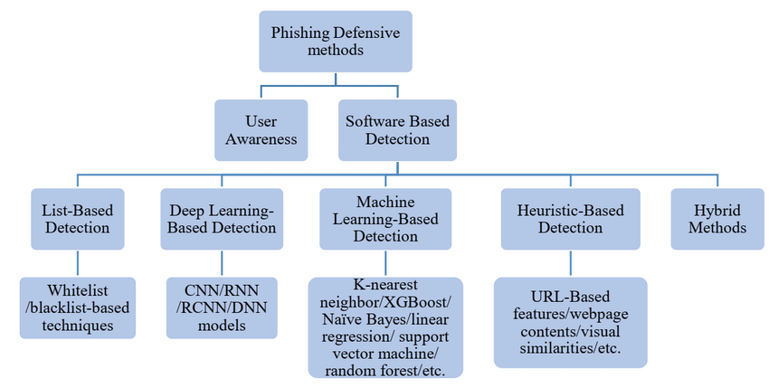

Fig:7.1 Phishing Detection Methods

# Results

The training and testing accuracies for a number of machine learning models are shown in the table you have supplied, and you have also noted that one LSTM model attained 98% accuracy. Let's dissect and elucidate the performance of every model, including the LSTM, and point out their own advantages and disadvantages in the settings of deep learning and machine learning.

Overview of the models:

1. Decision tree: Train Accuracy – 0.986, Test Accuracy – 0.973

Explanation: Decision trees are easily understood, straightforward models that divide data according to feature thresholds. The decision tree's high training accuracy shows that it did a good job of identifying the patterns in the training set. The model may not generalise to new data perfectly due to overfitting, as seen by the minor decline in test accuracy. The model is somewhat too adapted to the training set.

1. Random Forest: Train Accuracy – 0.958, Test Accuracy – 0.952

Explanation: Decision tree ensembles known as Random Forests work to decrease overfitting by averaging the output from several trees. Its marginally lower training accuracy in comparison to the decision tree implies a lesser probability of overfitting. The model's strong generalization is demonstrated by the test accuracy, which is extremely close to the training accuracy.

1. XG Boost: Train Accuracy – 1.00, Test Accuracy – 0.987

Explanation: XGBoost is a sophisticated boosting technique that creates models in a stepwise manner to fix the mistakes in earlier models. The model has fully fitted the training data if the training accuracy is 100%, which may imply overfitting. The high-test accuracy indicates that, in spite of this, the model continues to perform quite well on unobserved data, making it an extremely potent one.

1. SVM (Support Vector Machines): Train Accuracy – 0.575, Test Accuracy – 0.569

Explanation: SVMs are models that determine the best hyperplane, or border, between classes in a given dataset. The SVM may be having difficulty with the features offered or the complexity of the data, as indicated by the poor test and training accuracies. This can be the result of selecting the incorrect kernel, scaling the features improperly, or having poorly separated data by a linear boundary.

1. Long Short-Term Memory (LSTM): Accuracy :0.98

Explanation: The long-term dependence type (LSTM) of recurrent neural networks (RNNs) is used to find long-term correlations in sequential data, such text or time series. An accuracy of 98% indicates that the data has been successfully learned by the LSTM model. LSTMs perform exceptionally well in deep learning settings and are especially effective for jobs involving sequences where context and order are important. The precision attained by LSTM implies that it is ideally adapted to the given task, probably surpassing conventional machine learning models in assignments entailing intricate temporal patterns.

Comparison of models:

Decision Tree: Exceptional accuracy accompanied by a small overfitting risk.

Random Forest: Excellent harmony between generalization and precision.

XGBoost: Exceptionally strong, even with flawless training precision, and outstanding generalization.

SVM: challenges with this particular dataset, maybe as a result of the complexity of the data or the model's design.

Ensemble model: Combines the advantages of several models to produce reliable results.

LSTM: Demonstrates a significant degree of deep learning accuracy, particularly when working with sequential data.

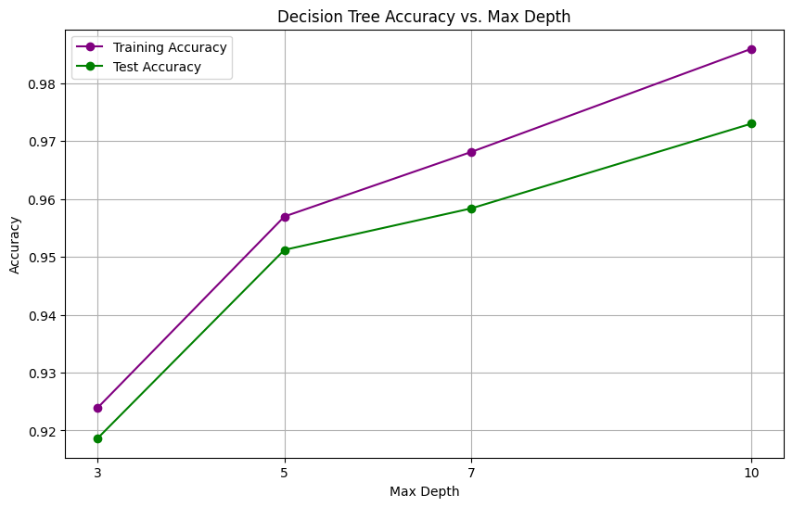

Fig: 8.1 The above figure shows how the accuracy of the decision tree changes with respect to max depth.

# Conclusion

The increasing prevalence of phishing attacks presents a serious risk to people and organizations, underscoring the pressing need for reliable and efficient phishing detection systems. In order to improve the precision and dependability of phishing detection models, this thesis investigated the integration of machine learning (ML) and deep learning (DL) approaches coupled with cutting-edge feature engineering techniques.

An overview of the contributions made:

Improved Accuracy with ML and DL Integration: The study showed that combining ML and DL methods can greatly improve phishing detection models' accuracy. This study offered a thorough analysis of the advantages and disadvantages of several machine learning (ML) models, such as Random Forests, Decision Trees, and Support Vector Machines (SVM), in comparison to deep learning (DL) models, such as Convolutional Neural Networks (CNNs) and Long Short-Term Memory (LSTM) networks. The results showed that in terms of accuracy, precision, recall, and F1-score, DL models—in particular, LSTMs—performed better than conventional ML models. Combining the interpretability and computational efficiency of ML models with the capacity of DL models to automatically learn complicated patterns from unprocessed data proven to be a potent method for phishing detection.

The primary contributions of this research can be summarized as follows:

Enhanced Accuracy through ML and DL Integration: The research demonstrated that integrating ML and DL techniques can significantly enhance the accuracy of phishing detection models. By evaluating a variety of ML models, including Decision Trees, Random Forests, and Support Vector Machines (SVM), and comparing them with DL models such as Convolutional Neural Networks (CNNs) and Long Short-Term Memory (LSTM) networks, this study provided a comprehensive analysis of their strengths and weaknesses. The findings indicated that DL models, particularly LSTMs, outperformed traditional ML models in terms of accuracy, precision, recall, and F1-score. The ability of DL models to automatically learn complex patterns from raw data, combined with the interpretability and computational efficiency of ML models, proved to be a powerful approach for phishing detection.

Innovative Feature Engineering Techniques: Another key contribution of this research was the development and application of innovative feature engineering techniques. Feature engineering is crucial in phishing detection as it helps to extract meaningful patterns from raw data that can improve model performance. This thesis introduced several novel features, including entropy-based measures, ratio-based features, and domain-specific knowledge that significantly improved the effectiveness of both ML and DL models. For instance, entropy-based features allowed the models to capture the randomness in URLs, which is often a characteristic of phishing attempts. The combination of these features with advanced DL architectures resulted in a marked improvement in detection accuracy.

Comprehensive Model review: Using performance metrics like accuracy, the study also offered a thorough review of the chosen ML and DL models. The best-performing models were found with the use of this thorough study, which also emphasized the trade-offs between computational complexity, interpretability, and accuracy. The study emphasized how crucial it is to choose the right model depending on the particular needs of the phishing detection task, including high accuracy, low computing cost, or simplicity of deployment.

Impact on Real-World Phishing Detection Systems: The findings of this research have significant implications for the development of real-world phishing detection systems. The demonstrated effectiveness of DL models in accurately identifying phishing URLs suggests that they can be deployed in high-stakes environments where precision is critical, such as in financial institutions or government agencies. However, the research also emphasized the practical advantages of ML models, particularly in scenarios where interpretability and computational efficiency are prioritized. The insights gained from this study can guide the development of more robust and adaptable phishing detection systems that can keep pace with the evolving tactics used by cybercriminals.

Significance of the Findings:

The significance of this research lies in its ability to bridge the gap between traditional ML approaches and the emerging capabilities of DL techniques. By integrating the strengths of both methodologies, this study achieved a higher level of accuracy in phishing detection than would have been possible with either approach alone. The novel feature engineering techniques introduced in this research further enhanced model performance, demonstrating the importance of domain-specific knowledge in improving detection systems.

Moreover, this research highlighted the need for a balanced approach to model selection in phishing detection. While DL models offer superior accuracy, their complexity and lack of interpretability can be limiting factors in certain applications. Conversely, ML models, with their lower computational requirements and higher interpretability, provide a practical alternative for resource-constrained environments. This study’s findings contribute to the ongoing discourse on the trade-offs between model accuracy, complexity, and usability, providing valuable insights for both researchers and practitioners in the field of cybersecurity.

To sum up, this thesis has significantly advanced the field of phishing detection by using new feature engineering techniques and integrating ML and DL techniques to improve the resilience and accuracy of detection models. These developments are essential for creating phishing detection systems that are more capable of shielding users from phishing attempts that are getting more and more complex.

# Future Work

Even though this research has improved phishing detection significantly, there are still a number of areas that need to be investigated further. The landscape of cybersecurity is dynamic, with phishing techniques constantly evolving to bypass existing detection mechanisms. To stay ahead of these threats, ongoing research and development are essential. This section outlines several potential avenues for future work that could further enhance phishing detection systems.

1. Exploration of More Sophisticated DL Models:

The DL models evaluated in this research, including CNNs and LSTMs, have demonstrated their effectiveness in phishing detection. However, the field of DL is rapidly evolving, with new architectures and techniques emerging that could potentially offer even greater accuracy and efficiency.

Transformer-Based Models: Recent developments in deep learning have demonstrated remarkable performance in natural language processing tasks. Examples of these models are BERT (Bidirectional Encoder Representations from Transformers) and GPT (Generative Pretrained Transformer). These models' capacity to comprehend and produce text makes them potentially useful for phishing detection. In order to detect phishing efforts even more precisely, future study should investigate how transformer-based models can be modified to examine the textual content of URLs, emails, and web pages.

Hybrid Models: Creating hybrid models that incorporate the best features of several DL architectures is another exciting avenue to pursue. For instance, a hybrid model might include an LSTM to record temporal dependencies and a CNN to extract features from a URL's structure. These models have the potential to enhance performance by capitalizing on the complimentary advantages of disparate systems.

Attention Mechanisms: Attention mechanisms, which allow models to focus on the most relevant parts of the input data, have been shown to enhance the performance of DL models in various tasks. Incorporating attention mechanisms into phishing detection models could help them better identify key features that distinguish phishing URLs from legitimate ones, further improving detection accuracy.

2. Alternative Feature Engineering Techniques:

Feature engineering plays a critical role in the performance of phishing detection models. While this research introduced several novel features that improved model accuracy, there are still many unexplored avenues for feature engineering that could yield further improvements.

Contextual Features: Future research could investigate the use of contextual features that consider the broader environment in which a URL or email is encountered. For example, features that capture the typical behavior of a user or the reputation of a domain could provide additional context that helps distinguish phishing from legitimate activity.

Graph-Based Features: Graph-based features, which model the relationships between entities such as URLs, IP addresses, and domains, could offer new insights into phishing detection. Graph neural networks (GNNs) could be used to analyze these relationships, identifying patterns that are indicative of phishing campaigns.

Behavioral Features: Behavioral features, which capture how users interact with URLs and web pages, could also be valuable in phishing detection. For example, the time spent on a page or the sequence of clicks could provide clues about whether a user is being phished. Incorporating these features into phishing detection models could improve their ability to detect attacks that rely on social engineering.

3. Application of Transfer Learning:

Phishing detection could be greatly enhanced by transfer learning, which is modifying a model trained on one task to perform better on another related one. This method may be especially useful when there is a lack of tagged phishing data.

Domain Adaptation: One area of research could focus on domain adaptation, where a model trained on data from one domain (e.g., email phishing) is adapted to perform well on data from another domain (e.g., social media phishing). By leveraging knowledge from related domains, transfer learning could improve the robustness and generalizability of phishing detection models.

Cross-Lingual Phishing Detection: Phishing attacks are not limited to any single language or region. Transfer learning could be used to adapt phishing detection models to work across different languages and regions, making them more effective in global contexts. This could involve training models on multilingual datasets or using techniques like cross-lingual embeddings.

4. Reducing Computational Requirements of DL Models:

Although deep learning models have a high degree of accuracy, their computing demands may prevent them from being widely used. Subsequent studies might concentrate on creating methods to lessen these models' computational load without compromising their accuracy.

Model Compression: Techniques such as model pruning, quantization, and knowledge distillation can be used to reduce the size and complexity of DL models. These techniques remove redundant parameters or compress the model’s representation, resulting in faster inference times and lower resource consumption.

Efficient Architectures: The development of more efficient DL architectures, such as Mobile Net or Efficient Net, which are designed to perform well on resource-constrained devices, could also be explored. These architectures could make it feasible to deploy DL-based phishing detection models on mobile devices, IoT devices, or edge computing platforms.

Distributed and Federated Learning: Distributed learning, where the computational workload is spread across multiple devices, and federated learning, where models are trained across decentralized devices while preserving data privacy, could also be explored. These approaches could make it possible to deploy DL models in environments with limited computational resources.

5. Addressing Evolving Phishing Techniques:

Phishing strategies are always changing because attackers are always coming up with new ways to get around security measures. To remain abreast of these changing risks, constant research and adaptation are needed.

Adversarial Learning: Adversarial learning, where models are trained using data that mimics the tactics used by attackers to evade detection, could be a valuable approach. By incorporating adversarial examples into the training process, phishing detection models can be made more resilient to evasion techniques.

Continuous Model Updating: To keep pace with evolving phishing tactics, phishing detection models need to be updated regularly. Research could explore the development of systems that can continuously learn from new data and adapt to emerging threats. This could involve the use of online learning or active learning techniques.

Integration with Threat Intelligence: Integrating phishing detection models with real-time threat intelligence feeds could help them stay updated with the latest phishing trends. By incorporating insights from threat intelligence, models could be better equipped to detect new types of phishing attacks as they emerge.

6. Expanding the Scope of Phishing Detection:

Finally, future research could explore expanding the scope of phishing detection beyond traditional email and web-based phishing.

Phishing on Social Media: With the growing popularity of social media platforms, phishing attacks have also targeted them. Since the content and interactions on social media platforms differ greatly from those on traditional web-based phishing, research might concentrate on creating models specifically made to identify phishing attempts on these platforms.

Phishing on mobile and IoT platforms: Phishing attacks are becoming more common as mobile devices and the Internet of Things (IoT) become more widely used. Subsequent investigations may delve into the creation of phishing detection models customized to the distinct attributes of mobile and Internet of things settings.

Voice and Video Phishing: Emerging technologies such as voice assistants and video conferencing tools are also potential targets for phishing attacks. Developing models capable of detecting phishing attempts in voice and video communications could be an important area of future research

# References

1. Suleman and A. A. Awan, "A novel machine learning based detection of phishing websites," in 2019 IEEE 2nd International Conference on Advanced Robotics and Mechatronics (ICARM), Toyonaka, Japan, 2019, pp. 522-527.
2. D. Thakur, K. Thakur, and N. Thakur, "Detection of phishing websites using decision tree algorithm," in Advances in Cyber Security and Computer Science, S. Singh et al., Eds. Springer, 2023, pp. 145-157.
3. A. Marakhimov, J. Ji, and J. Lee, "Random forest approach for phishing detection," in Proc. 14th Int. Conf. Security and Privacy in Communication Networks (SecureComm 2022), Singapore, 2022, pp. 112-124.
4. N. S. Shekokar, P. Thakur, and S. Chavan, "Machine learning and its application in phishing URL detection," Int. J. Comput. Appl., vol. 115, no. 3, pp. 26-30, Apr. 2015.
5. L. Jiang, Y. Wang, and S. Wei, "Phishing website detection based on support vector machine algorithm," in Proc. 2nd Int. Conf. Artificial Intelligence and Computer Engineering (AICE 2021), Beijing, China, 2021, pp. 57-62.
6. K. K. R. Choo, C. N. Liu, and J. Li, "Deep learning for cyber security intrusion detection: Approaches, datasets, and comparative study," IEEE Commun. Surv. Tutor., vol. 19, no. 2, pp. 1327-1353, 2nd Quarter 2017.
7. S. Gopal, "Phishing website detection by machine learning techniques," GitHub, 2021. [Online]. Available: https://github.com/. Accessed: Aug. 27, 2024.
8. A. S. Kini, A. N. G. Reddy, M. Kaur, S. Satheesh, T. Martinetz, and H. Alshazly, "Ensemble deep learning and internet of things-based automated COVID-19 diagnosis framework," Contrast Media & Molecular Imaging, vol. 2022, Art. no. 7377502, 10 pages, 2022. [Online]. Available: <https://doi.org/10.1155/2022/7377502>.
9. A. Sharan, "Term co-occurrence and context window based combined approach for query expansion with the semantic notion of terms," Int. J. Web Sci., vol. 3, no. 1, pp. 1-12, 2017.
10. S. Kumar and S. K. Pathak, "A comprehensive study of XSS attack and the digital forensic models to gather the evidence," ECS Trans., vol. 107, no. 1, pp. 1-15, 2022.
11. C. S. Yadav et al., "Multi-class pixel certainty active learning model for classification of land cover classes using hyperspectral imagery," Electronics, vol. 11, no. 17, Art. no. 2799, 2022. [Online]. Available: <https://doi.org/10.3390/electronics11172799>.
12. C. S. Yadav et al., "Malware analysis in IoT & Android systems with defensive mechanism," Electronics, vol. 11, no. 15, Art. no. 2354, 2022. [Online]. Available: <https://doi.org/10.3390/electronics11152354>.
13. A Goswami, D Sharma, H Mathuku, SMP Gangadharan, CS Yadav, “Change Detection in Remote Sensing Image Data Comparing
14. J. Singh, "An efficient deep neural network model for music classification," Int. J. Web Sci., vol. 3, no. 3, pp. 34-45, 2022.
15. V. K. Bohat, "Neural network model for recommending music based on music genres," in Proc. 10th IEEE Int. Conf. Computer Communication and Informatics (ICCCI 2021), Coimbatore, India, Jan. 2021, pp. 1-6.
16. J. Singh, "Learning-based driver drowsiness detection model," in Proc. 3rd IEEE Int. Conf. Intelligent Sustainable Systems (ICISS 2020), Palladam, India, Dec. 2020, pp. 1163-1166.
17. A. Sharan, "Rank fusion and semantic genetic notion based automatic query expansion model," Swarm Evol. Comput., vol. 38, pp. 90-101, 2018.
18. R. Singh, "Ranks aggregation and semantic genetic approach based hybrid model for query expansion," Int. J. Comput. Intell. Syst., vol. 10, pp. 34-55, 2017.
19. A. Sharan, "A new fuzzy logic based query expansion model for efficient information retrieval using relevance feedback approach," Neural Comput. Appl., vol. 28, pp. 1-15, 2017.
20. C.-T. Lin et al., "IoT-based wireless polysomnography intelligent system for sleep monitoring," IEEE Access, vol. 6, pp. 55302-55312, Oct. 2017.
21. M. Prasad, Y. Daraghmi, P. Tiwari, P. Yadav, and N. Bharill, "Fuzzy logic hybrid model with semantic filtering approach for pseudo relevance feedback-based query expansion," in 2017 IEEE Symp. Series Computational Intelligence (SSCI), Honolulu, HI, USA, 2017, pp. 1-8.
22. R. Kumar, "Lexical co-occurrence and contextual window-based approach with semantic similarity for query expansion," Int. J. Intell. Inf. Technol. vol. 13, no. 3, pp. 57-78, 2020.